

**Course Title:Electrical Circuits**

**Course: CSE251**

**Lab Report (5)**

**Section: 5**

**Date: 12.1.22**

**Submitted by:**

Student name:Md.Abu Zafor

Student Id:2020-2-60-158

**Submitted to:**

Touhid Ahmed

Lecturer Department of Computer Science & Engineering

**Experiment Title:** Signal Integration and Differentiation Using 741 Op-Amp.

**Objective:**

1. To study the responses of Op-Amp integrator to sinusoid and square waveforms.

2. To study the responses of Op-Amp differentiator to sinusoid and triangular waveforms.

**Circuit Diagram:**

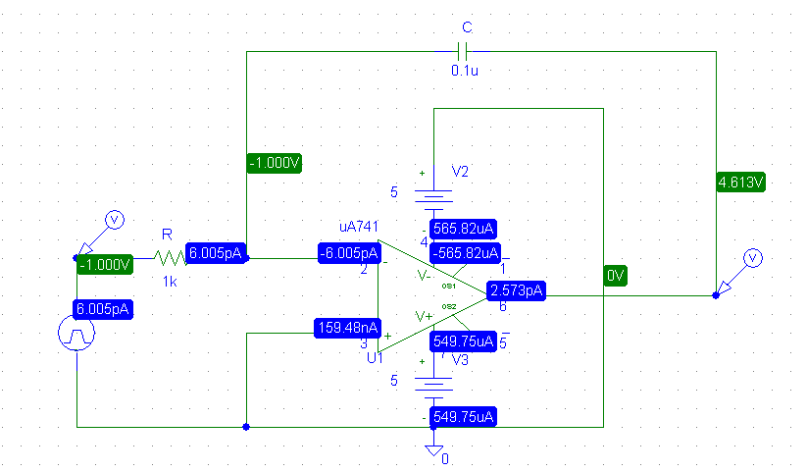

**Figure 01:**An op-amp integrator circuit

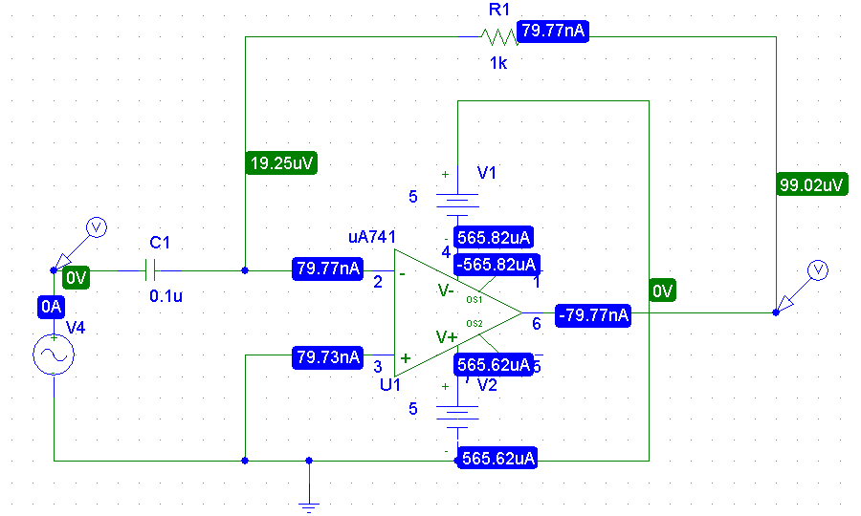

Figure 02:An op-amp differentiator circuit.

**Post lab question answers:**

**Integrator**

**Answer No: 1**

Here, R = 1Kohm, C = 0.1uF, Vp = 1.76V, f = 796Hz

We know,

Amplitude

=

1.76 /(2∗3.14∗796∗1∗0.1)

=3.52 V

Comparison between the Calculated & Measured value of the

amplitude of output signal:

Calculated Value = 3.52V and Measured Value = 3.52V

There is no difference since the experiment done on simulation.

**Answer No: 2**

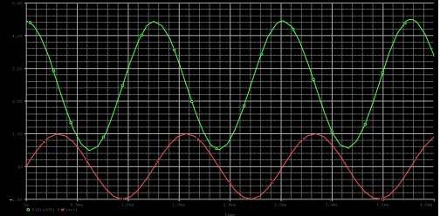

Here,

Tout = 1.257ms

Tin = 0.943ms

We know,

Phase diff = 360 * f * Δt

= 360 * 0.795 * (1.257 – 0.943)

= 89.67

Pre lab Value: 90

Measured value: 89.67

From the data we can see that there is a slight difference between the Pre-lab value & measured value of the phase difference. That difference due to instrumental error

**Answer No: 3**

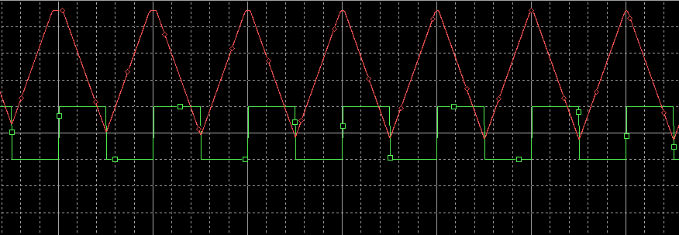

Figure: Integrator simulation.

**Output signal:**

Simulation value: 2.78

Measured value: 3.52

From the above table we can see that there is a slight difference between the Simulation value and measured value

**Differentiator**

**Answer No: 4**

Here, R = 1Kohm, C = 0.1uF, Vp = 1.76V, F = 796 Hz

We know,

Amplitude Vo = Vp RC ω

= 1.76 * 1 * 0.1*10^-6 * 2 * 3.14 * 796

= 0.879V

Calculated value: 0.879V Measured value: 0.84V

We see that there is a difference between the two values.

**Answer No: 5**

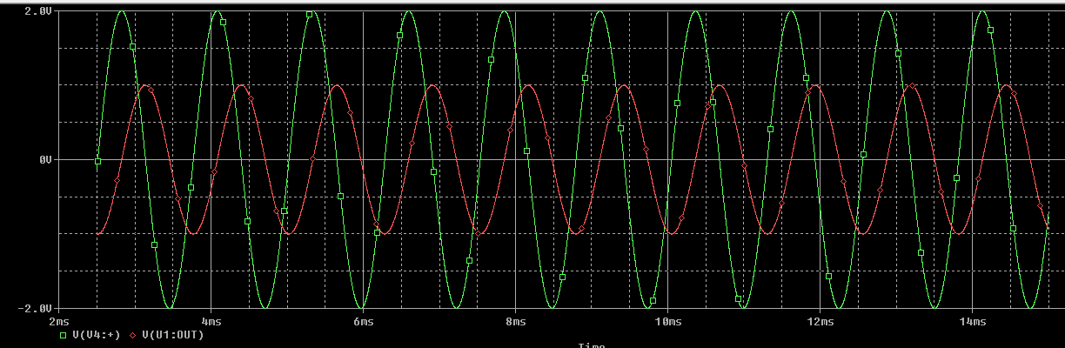

Here,

Tout = 2.8345ms

Tin= 2.5176ms

We know,

Phase diff = 360 * f * Δt

= 360 * 0.795 * (2.8345 – 2.5176)

= 90.696

Pre lab Value: 90

Measured value: 90.696

From the data we can see that there is a slight difference between the Pre-lab value

& measured value of the phase difference. That difference due to instrumental

error.

**Answer No: 6**

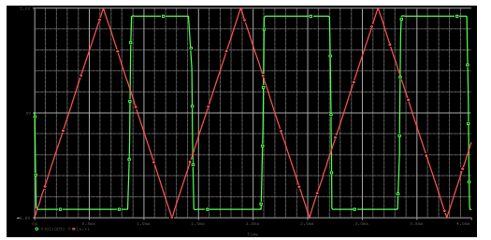

Figure: Differentiator simulation.

Comparison between the simulation and measured value of the output signal:

Simulation value: 0.62

Measured value: 0.84

From the above table we can see that there is a slight difference between the Simulation value and measured value.

**Conclusion:**

We used a 741 OpAmp to simulate the differential and integral circuit in this experiment. We also learn how to use PSPICE to simulate differential and integral circuits for both square and triangular waves. There were some outcomes that differed from the expected values. These mistakes might happen for a variety of reasons.